Test Environment Notes

This project includes a sample of an automation test framework and some automated test scripts using C# and Selenium Webdriver (v3.141.0). These test scripts are to very some basic functions of the Wordpress website (v5.2.2) that is installed in my local computer. A local server (XAMPP) and MySQL database are also installed in my computer.

**MySQL database**

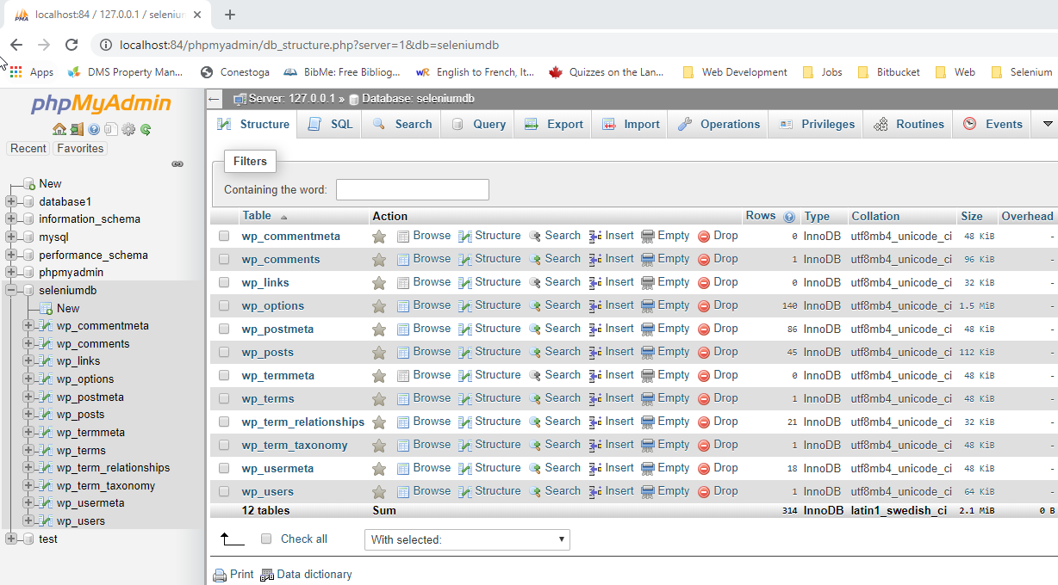

**Wordpress website**

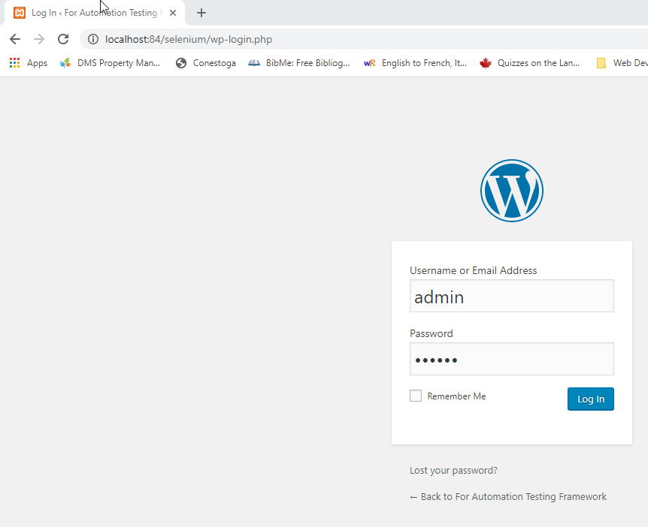

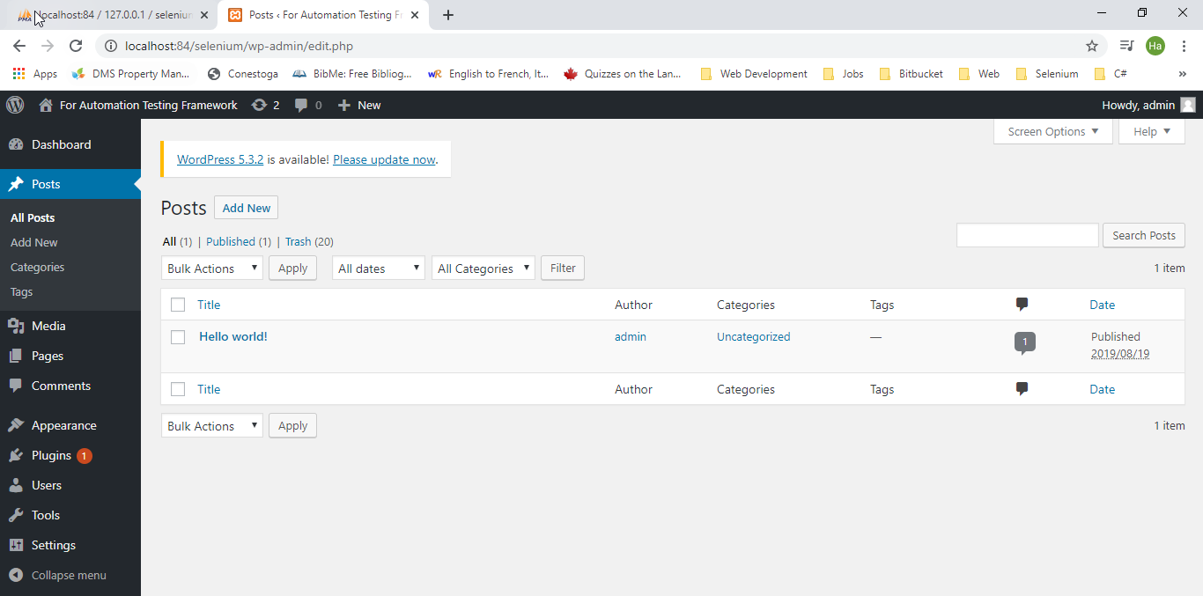

**A local server**

